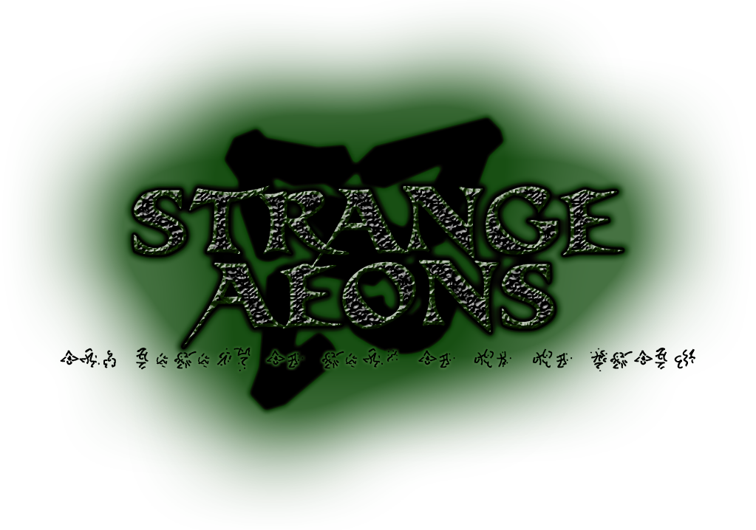

11th-13th June 2010 – Durham University Treasure Trap 3YGB – Raven Gill Camp Site
In the dark corners of the world, in the tunnels beneath our feet, in shadows and back-alleys and hidden temples, a war is being fought. It is not the kind of war sung of by bards – or if it is, they sing softly for fear of a poisoned blade from an unseen and unimpressed listener. It is not the sort of battle for armies; it is war conducted with poisoned knives, with fell magic, with the aid of demons. It is a war fought underground, in every sense of the word.
Every element has a master; a dictator, an owner, an Elemental Lord who rules absolutely. Grome claims dominion over the earth, the very stability and solidity of the world; Ariel over the air, over movement and change. Kakatal, lord of fire, destroys what he touches, while Straasha of the waters brings new growth in his wake. Glowing in the light of the stars, serene Elbereth sees all things.
Darkness has no master. In the shadows and mazes of the deep underground, in confusion and misdirection and lies, there is a twisted form of freedom. No Lord; only the Titans, vast elemental beings struggling among themselves, rising and falling as they strive to own their element, conquer their foes, define what darkness is beyond merely the absence of the light.
The Titans begin to feel the cost of their war. Their element is weakened against those with one ruler; always defined by absence, by edges, by what is missing, it is beginning to be driven in upon itself. As they battle one another, they lose ground against their common foes. Now as never before, the Titans reach out to their children among the drow and their servants among the mages; more and more they demand focus from their followers, demand achievement rather than endless war for its own confusing sake. There is not enough time to let their contest play itself out; all shades must be of the same length, all darkness must be one darkness.
The only question that remains: whose?
- Shadows of the Titans: though they are elementals of incredible power and focus, building their armies from their lesser kin, Titans have fallen before. Any elemental of enough drive and power could take their place. For now the elementals wait, courtiers and bodyguards to which master best suits their whims; some act with loyalty, some merely waiting for the time to strike, but all knowing that the very nature of their souls is at stake in their cousins’ deadly game.

- Heirs to Darkness: Drow, the elves whose souls rise to join the ranks of the elementals on death, flock to the Titans’ banners, following the powers that saved their ancestors from slavery and extinction at the Dragonlords’ hands so long ago. They form the Titans’ armies, lead their cults, and summon their elementals into the world to bring their power to bear; they are the titans’ children and foot soldiers, born into their power, throwing themselves headlong into battle for their masters in the hope of favour when their soul escapes to eternal life in the Titans’ dominions.

- Dabblers in the Murk: Unbound by any ancient pacts, driven by their own needs and curiosities alone, mortal mages who study the arts of darkness are a mixed bunch; some view themselves as priests of a sort, converts to the faith, while others are pragmatists who wield arcane might to their own ends. Nonetheless, when the Titans touch their foci, they take a measure of allegiance, and even such inconstant allies must now be brought to bear.

- Titan-Touched: Reaching into the world, the Titans empower champions much as the Elemental Lords possess Avatars; mages with souls bound irrevocably to shadow and elves whose souls align so closely with the titan as to be part of it. These masters of magic build cults, gather hidden armies, and act as their patrons’ hands and eyes in all things.

- Lives Lived In Shadow: Across the world, the powers of darkness have often crossed paths with the unscrupulous and the power-hungry; Black mages are hunted, viewed with suspicion; drow driven out or burned for fear of child-stealing and well-poisoning. Not all of this reputation is undeserved; those who deal with demons, whose criminal empires and conspiracies stretch across whole nations and beyond, have no few reasons to seek the blessings of the dark. Cabals within the Children of the Light study witchcraft; kings and criminals, churches and tradehouses, all turn to darkness to hide their secrets; those in the thrall of demons alert their patrons to the fascinating opportunities the shadow war allows, the possibility of usurping an entire element into their own incomprehensible games.

- Prisoners in the Umbra: For some, the touch of darkness lies heavy upon them. Sacrificed to the Elemental Titans in dire rituals, driven insane by what they have seen, or physically transported to the Titans’ domains by ritual or mishap, other souls become the playthings of the masters of shadow and their loyal servants.
OC Details and Booking
This event will be 24-hour-time-in, from the evening of Friday the 11th of June to the early afternoon of Sunday 13th, 2010, at Raven Gill Camp Site in the North Yorkshire Moors. It will be fully catered, and there will be bunks for everyone attending, players or crew, so no need to camp! For those travelling from Durham a coach will be arranged to take people from DSU to the site on Friday and bring them back at the end of the event, and details of how to reach the site will be provided to everyone else on booking confirmation.
The characters for this event will be pre-generated: once you’ve filled out the booking form with your preferences, we will write a character around what you want to play and send you a full brief. The event will use the same rules as the main system, with some flourishes and event-specific additions; the Head Ref for this event is Freya Copley-Mills, and the writing/ref team to date is Helen Dabill, Tim Packer and Will Thorley. If anyone in their first/second year would be interested in helping to write & ref the event, we’re still looking for one more person, preferably from among the society’s active internals!
It’s worth noting - while the main point of this event is to give an end-of-year send-off to TT regulars who are graduating, and Durham third-years will be given priority for major roles or whatever they particularly want to be, the most unexpected characters at these events frequently win harder than should be physically possible, and we love having externals and people from other events come along, to play or to crew. This event is very much open invite! Bring awesome people!
And without further ado: the form!

Strange Aeons Booking Form
The booking deadline for this event is the 28th of April, 2010; that’s the first Wednesday of Summer Term, for all you Durhamites. After that we can still take bookings for crew places, but we need character forms in by then!
Player Name: _____________________________________________________

Email Address: _____________________________________________________

I Want to Character [ ] …but will Crew if needed [ ]
I Want to Crew [ ] …but will Character if needed [ ]
Character places will cost £40; Crew places will cost £5. Crew will be asked to help prepare and serve food, keep the place tidy, and play multitudinous gribblies and NPCs, but will also have minor characters to play in their spare time (as well as our eternal gratitude).

Would you like: Transport from Durham [ ] Directions to the site [ ]
If you’d like us to arrange transport, it will be via minibus/coach and will get you to the event on Friday and back again on Sunday, from DSU. Transport will cost more on top of the main event price – cost of transport divided between everyone who needs it.

Are you a third year? [ Y / N ]
Indicate YES if you are a third year at Durham, or if you are graduating and leaving Durham and have not yet counted as being a third year at one of these events, or if you’ve been in the society for more than three years and haven’t had a third-year goodbye yet, or it’s been three years or more since your last third-year goodbye. If you reckon you should count as a third year under any other circumstances, or if you for some reason don’t want to count as a third year this year, let us know

Any medical conditions, food allergies or food requirements our caterers and first-aiders should be aware of? [ Y / N ]
If yes, please give details here.

Character Generation
Please tick boxes in this section which you’d like to describe your character.

[ ] I want to be after great powers
[ ] I want great powers to be after me
[ ] I want to have great powers
[ ] I want great powers to have me
[ ] I want to know everything
[ ] I want to know something
[ ] I want to know nothing
[ ] I want to use makeup and prosthetics
[ ] I want no makeup and prosthetics
[ ] I want a high phys-rep requirement
[ ] I want a medium phys-rep requirement
[ ] I want no phys-rep requirement
[ ] I specifically want to make/use this awesome bit of kit: _____________________
_______________________________________
[ ] I want to be a good guy
[ ] I want to be a bad guy
[ ] I want moral ambiguity, damn you
[ ] I want friends
[ ] I want co-conspirators
[ ] I want minions
[ ] I want to be a minion
[ ] I want to be alone
[ ] I don’t want any romantic storylines
[ ] I enjoy PvP plotlines
[ ] I’d sooner mainly fight monsters

[ ] Drow
[ ] Demon
[ ] Elemental
[ ] Mage
[ ] Cultist
[ ] Conspirator
[ ] Lunatic
[ ] Victim
[ ] Something Else, Specifically A:__________
______________________________________

[ ] I’m unfamiliar with the TT setting or would just like my role not to rely on that.
[ ] I’m unfamiliar with the TT rules or would just like to have very simple stats and rules.
[ ] I have exams shortly before the event or would otherwise like as little to memorise as possible!

Please prioritise these options for what your character does: 1 is most preferred, down to 7 is least.
[ ] Fighty – warrior skill tree, combat tank or otherwise violence-oriented.
[ ] Sneaky – scouting and alchemy skill trees, stealth and poisons, or otherwise larcenous in skill set.
[ ] Magical – elementalism skill tree or flange-empowered with various spells by some means.
[ ] Demons Demons Demons – demonology skill tree, demon minions, demon pacts and rituals.
[ ] Thinky – Plans, schemes, plots, puzzles and generally knowing everyone else’s business.
[ ] Talky – Politics, negotiation, social wrangling, and generally smooth-talking your way to victory.
[ ] Shinies! – Magic items, many phys-reps, and having a toolkit of stuff to throw at problems.

Last But Not Least – Please Think Carefully
[ ] I WANT TO BE SCREWED OVER BY PLOT
Ticking this option is playing on Hard Mode: your character will start in a losing position for achieving their goals, due to circumstances beyond your control! If you won’t enjoy an uphill struggle, finding out you have the completely wrong end of the stick IC, genuinely impossible goals or facing overwhelming opposition, don’t choose this option!

Ex Miscellanea
If there’s anything you’d like that isn’t covered above, or if you’d definitely like or not like something specific, add it below. Any amount of detail is fine – anywhere from “I’d like to have this specific skill” or “I’d like to have a good excuse to get drunk and shout a lot” to a full background and a complete stat sheet (but we don’t promise not to change it). If there’s anyone you’d very much like to be able to roleplay with at the event, let us know so we can arrange for your characters to know one another!

